**Title of Research paper (20 font size bold, Centered Position, Times New Roman)**

**First Author1, Second Author2, Third Author3 (Times new roman with 12 font size bold)**

*1First author affiliation/designation, University address, City, Country, Email (Times new roman italic, 10 font size)*

*2Second author affiliation/designation, University address, City, Country, E-mail*

*3Third author affiliation/designation, University address, City, Country, E-mail*

Abstract- Abstract should be times new roman, bold, 9 font size with 1.0 line spacing.

**Keywords – Minimum 3 Keywords and should be in times new roman with 9 font size bold.**

**JSRT paper format should adhere mentioned guidelines below:**

* Title of Research paper: -Times New Roman, 20 font size bold, Centered Position.
* Author Names: - Times New Roman, 12 font size bold, Centered Position.
* Author affiliation/designation & other details as mentioned above must be in Times new roman *Italic*, 10 font size (Not Bold), centered position.
* Abstract- Abstract should be times new roman, bold, 9 font size with 1.0 line spacing.
* All headings, Sub-headings(sub-headings should be left positioned), figures, tables or any other extra content headings should be in times new roman with **10** font size **bold** & in centered position.
* Sub-headings should be left positioned with 10 font size
* Remaining body of the paper should be in times new roman 10 font size (Not bold).
* Paper should be in Single column. Line Spacing should be maintained with **1.0** in whole document, **justified**.
* Author must submit only word (doc/docx) file/paper. PDF or any other type of file is not accepted.
* Maximum **6** authors and maximum **28** pages accepted (charges applicable if number of authors and pages exceeds & same will be notified in acceptance mail)

**Note to all authors: -**

**Plagiarism** of the research paper should not exceed more than **15%**. We use **Turnitin** software for plagiarism check.

* For **paper writing** assistance and **plagiarism** concerns or any queries kindly get in touch with us**:**
* **WhatsApp Only: +91-8660261103 (10:30am-6pm IST)**
* **Sample paper is given below for further convenience**:

I. INTRODUCTION

A snowball battle is a rough game in which snowballs are thrown at opponents in an effort to hit them. The game is similar to dodgeball in many aspects, but it is typically less organised. When there is adequate snow, this pastime is primarily enjoyed during the winter. Into Northern USA & Europe, ice hockey is well-liked team sport. It is characterised as a liquid game [1], [2], by performers regularly coming on and going off ice without breaks. Hockey games are fun to watch, but because to low scores [2] as well as complex dynamics [3, 4], usage of analytical methods to measure participant act is quiet in its infancy. In the realm of sports analysis, assessing individual player performance and their impact on team performance [5], [6] is a significant difficulty. For purpose of measuring performance in various team sports, many measures have been devised, such as "Expected-Point-Value" into basketball. "Expected-Goal-Value" into football [9, 10]. Winning the ultimate championship of a specialized ice hockey league, like NHL into Northern USA, is highest honor and aim of all performers as well as groups. Many questions emerge as a consequence, including how to assemble an effective team with people who give their all, and what plans to devise based on an examination of numerous offensive and defensive techniques.

**II. LITERATURE REVIEW**

Weissbock, J.[1], In this research, we examine a range of methods for predicting outcome of ice hockey games, focusing on National Hockey League (NHL). All sports, it seems, have a theoretical top limit, which makes it more difficult to forecast outcomes. Predicting result of individual games in this thesis is focus of first portion of research. Standard data (which can be found on league's website, are commonly cited by media) enactment indicators are used in our analysis. For our model to achieve a 59.8% accuracy rate, we relied on conventional statistics, despite its long success of performance measures in field of autonomous game prediction Intriguingly, we couldn't get our model's accuracy over 60% no matter which characteristics we included into it. For single-game prediction in NHL, a theoretical top limit of 62 percent seems to be in place, based on observed win percentages of NHL group.

**III. PROPOSED SYSTEM**

By combining individual player location information with team uniform colours For detection of participants in ice snowball games, we construct 2-phase cascaded Convolutional Neural Network (CNN) prototypical. At this point, we've gotten rid of everything that would detract from finding players we're looking for, such as crowd and any sideline advertising. This phase takes into account more specific data, such as player-specific occlusion of body position and uniform coloration across teams, in order to improve final results. It also uses distribution of aspect ratios across all players in training datasets in an effort to develop an effective deep learning framework for dealing with difficult situations involving players in various postures. Individuals and teams may be accurately and efficiently identified based on outcomes of test dataset.

**IV. IMPLEMENTATION**

**RESULTS AND DISCUSSION**

**Two-phase cascaded CNN model**

Representation design of our suggested 2-phase cascaded neural network architecture is presented in figure below, with Phase I coloured yellow and Phase II coloured blue, correspondingly, branching from backbone network, as shown in figure. There are three main phases in procedure: An image patch is first processed by convolution layer Conv-B1 with 16 filters of size 33, guided by an activation layer containing a Rectified Linear Unit (ReLU) to speed up learning rate junction as well as prevent optimised function from becoming stuck in saddle points or local minima by reducing computational complexity.

**V. SYSTEM ARCHITECTURE**

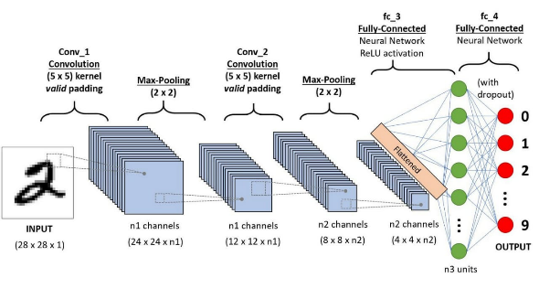

**Figure 1: System Architecture**

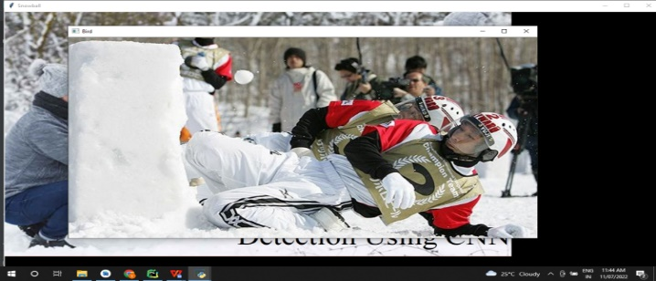

**Figure 3: Input Image**

**Table -1 Experiment Result**

|  |  |  |
| --- | --- | --- |
|  | Original Lena Image (PSNR) | Watermarked Lena Image (PSNR) |
| BJUT Watermark Image |  |  |
| Bobbol Watermark Image |  |  |

**VI. CONCLUSION**

Coaches and other game analysts must respond swiftly to ensure that participants in ice snowball games are accurately and automatically detected. 2-phase integrated CNN model was planned into this study to identify separate performers annotated by team connections using a self-created dataset. Picture and video feeds allow us to reliably identify players and their teams. There are 91.30 percent and 95.60 percent accuracy as well as recall rates, respectively, for distinct participant identification in ice hockey games at Winter Olympics. Average correctness of squad categorization is 93.05. Temporarily, we are running our model on a dataset that includes all of the teams in the league, and we are successfully detecting performers as well as their team associations from picture in addition video inputs.

**REFERENCES**

1. Weissbock, J., Forecasting Success in the National Hockey League using In-Game Statistics and Textual Data. 2014, University of Ottawa Canada.
2. Schuckers, M. and J. Curro. Total Hockey Rating (THoR): A comprehensive statistical rating of National Hockey League forwards and defensemen based upon all on-ice events. in 7th annual MIT sloan sports analytics conference. 2013.
3. Mehrasa, N., et al., Deep learning of player trajectory representations for team activity analysis, in 11th MIT Sloan Sports Analytics Conference. 2018.
4. Tora, M.R., J. Chen, and J.J. Little, Classification of Puck Possession Events in Ice Hockey. 2017 IEEE conference on computer vision and pattern recognition workshops (CVPRW), 2017: p. 147--154.